**BLOCK DIAGRAM:**

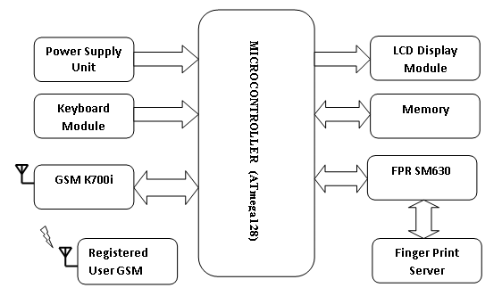

**INTRODUCTION**

# In this project, we have created a model for making use of biometrics outfitted ATMs (Automatic Teller Machines) to supply a lot of social services comprising verification of identity and providing social safety, unemployment, well-being, and pension benefits to a huge section of the population.

# HIGH LEVEL REQUIREMENT:

# The ATM must service at most one person at a time. The number of invalid pin entries attempted must not exceed three. After three unsuccessful login attempts, the card is seized/blocked and need to be unlocked by the bank. The simultaneous access to an account through both, the ATM and the bank is not supported.

# LOW LEVEL REQUIREMENT:

# One major dependency that the project might face is the changes that need to be incorporated with the changes in the bank policies regarding different services. As the policies changes the system needs to be updated with the same immediately. A delay in doing the same will result to tremendous loss to the bank. So this should be changed as and when required by the developer. Another constraint relating to the operating environment is that we are specific to Oracle Database.